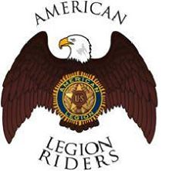

Dear Prospective Member:

The American Legion has established an American Legion Riders program with all posts eligible to set up a chapter. The Joseph N. Neel, Jr. Post 3 in Macon has elected to start up and support a chapter of Legion Riders.

The mission of the Department of the Georgia American Legion Riders is to promote and support the aims and purposes of The American Legion:

- The rehabilitation of all disabled veterans;
- Care of the dependents of those who have answered the final call;
- Care of those who are suffering from wounds, disease and want;
- The education of our children;
- Service to the community, state and nation.

American Legion Riders are composed of Legionnaires, Auxiliary, and Sons of the American Legion who share a passion for riding motorcycles. We support the values of The American Legion by riding in patriotic parades, funeral escorts, and participating in programs, events and other ceremonies in the communities in which we live, work, and play. American Legion Riders have an unwavering respect for our country, our flag, and for those who risk their very lives for America’s freedom and security.

Should you have any desire to discuss joining our new chapter at Post 3, please do not hesitate to contact me. For God and Country.

Very truly yours,
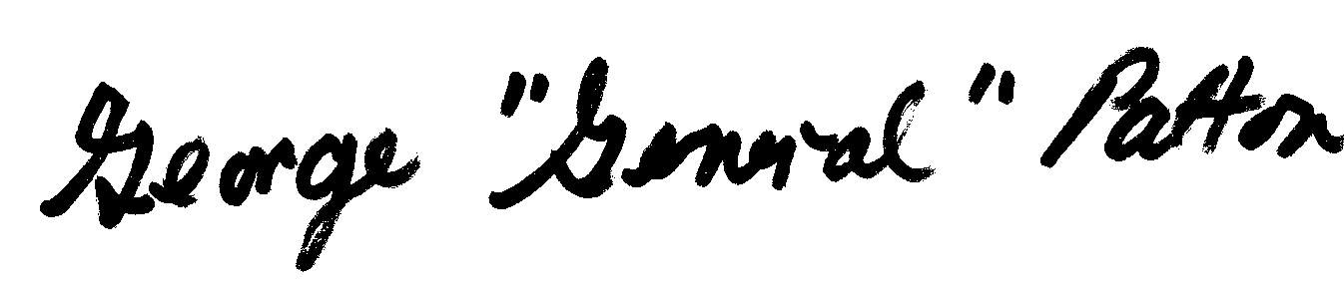
George “General” Patton
Riders Director, Post 3 Macon GA
Email: georgepattonjr44@att.net
Cell: (478) 719-7396

